Semester Project  Summer 2026 |   Team: RS Debugers

Submited By-

Rafiur Rahman(0242310012091037)
ASM Mohaiminul Islam(0242310012091033)
Smaron Biswas(0242312091013)
SubmitedTo- | Hridoy Das  Designation:lecturer  Daffodil International University
Project Title : Software Quality Assurance and Testing of the Add to Cart and Checkout Features of CBX Shop E-Commerce Website.

Introduction
This Software Quality Assurance project evaluates the Add to Cart and Checkout features of CBX Shop, a Bangladeshi e-commerce website. These features are essential because they allow customers to select products, update quantities, review prices, enter delivery information, choose a payment method, and complete an order.
The project follows a complete SQA workflow, including requirement analysis, requirement finalization, test-case design, manual test execution, test reporting, bug analysis, and automation testing using Playwright with JavaScript and the Page Object Model design pattern. Both functional and non-functional aspects are tested, such as cart operations, input validation, price calculation, order placement, page-loading performance, responsiveness, and cross-browser compatibility.
The main purpose of this project is to identify defects, compare expected and actual results, and evaluate whether CBX Shop provides a reliable, accurate, and user-friendly purchasing experience. The findings and defect reports can help improve the quality, performance, and usability of the website.

Phase I — Requirement Analysis

Project Information
Application: CBX Shop
Website: https://cbxshop.com/
Application Type: E-commerce website
Selected Features: Add to Cart and Checkout
Target Users: Customers purchasing products from CBX Shop

Stakeholder/User Interview Questions and Answers
Q&A ID | Requirement Question | Answer from User/Stakeholder Perspective
QA_001 | Should a customer be able to add a product to the cart without creating an account? | Yes. A customer should be able to add products to the cart and continue as a guest without registration or login.
QA_002 | What information should appear after a product is added to the cart? | The cart should show the product name, image, price, selected quantity, subtotal and available cart actions.
QA_003 | Can a customer add more than one quantity of the same product? | Yes. The customer should be able to select multiple quantities before adding the product or update the quantity from the cart.
QA_004 | What should happen when the same product is added more than once? | The existing product quantity should increase instead of creating unnecessary duplicate cart entries.
QA_005 | Can a customer add multiple different products to the cart? | Yes. All selected products should appear separately with their correct details and quantities.
QA_006 | Should an out-of-stock product be added to the cart? | No. The Add to Cart option should be unavailable, or the website should display an out-of-stock message.
QA_007 | Can the customer update the product quantity from the cart? | Yes. The customer should be able to increase or decrease the quantity, and the subtotal should update correctly.
QA_008 | Can the customer remove a product from the cart? | Yes. The cart should provide a remove option, and the total should be recalculated after removal.
QA_009 | Should cart information remain after refreshing the page? | Yes. Added products and quantities should remain in the cart after a normal page refresh.
QA_010 | What should happen when the customer clicks “Proceed to Checkout”? | The customer should be redirected from the cart page to the checkout page with the selected products and calculated total.
QA_011 | What customer information is required during checkout? | The customer must provide a name, valid phone number and full delivery address. Email may be optional according to the current checkout form.
QA_012 | What should happen if required checkout fields are empty? | The order should not be submitted. The website should show validation messages for the missing required fields.
QA_013 | Should the website accept an invalid phone number? | No. It should reject an incomplete or incorrectly formatted phone number and display a validation message.
QA_014 | What payment methods should be available? | The customer should be able to use the payment methods currently supported by CBX Shop, including Cash on Delivery when available.
QA_015 | How should the final order total be calculated? | The final total should be calculated from product subtotal, discounts if applicable and delivery charges.
QA_016 | What should happen after a successful order is placed? | The website should display a confirmation message such as “Thank you. Your order has been received,” along with relevant order information.
QA_017 | Should customers be able to place an order with an empty cart? | No. The checkout process should be blocked when the cart contains no products.
QA_018 | Should double-clicking the Place Order button create multiple orders? | No. Only one order should be created, even if the customer clicks the button multiple times quickly.
QA_019 | Should the cart and checkout features work on mobile devices? | Yes. All fields, buttons, product details and cart information should be readable and usable on mobile screens.
QA_020 | How quickly should Add to Cart and Checkout actions respond? | The website should provide a visible response within a reasonable time. A loading indicator should appear if processing takes longer.

Phase II — Requirement Finalization
Based on the Requirement Q&A, the following functional and non-functional requirements are finalized.

2.1 Functional Requirements — Add to Cart

Requirement ID | Finalized Requirement | Priority | Acceptance Criteria
FR_CART_001 | The system shall allow a customer to add an available product to the cart. | High | After clicking Add to Cart, the selected product appears in the cart.
FR_CART_002 | The system shall allow a customer to select multiple quantities of a product. | High | If quantity 3 is selected, the cart displays quantity 3.
FR_CART_003 | The system shall allow a customer to add different products to the cart. | High | Every selected product appears separately with correct information.
FR_CART_004 | The system shall correctly handle the same product being added more than once. | Medium | The product quantity increases or is combined according to the website’s cart behaviour.
FR_CART_005 | The system shall prevent an out-of-stock product from being added. | High | The Add to Cart button is unavailable, or an out-of-stock notification appears.
FR_CART_006 | The system shall require customers to select mandatory product variations where applicable. | High | A product requiring size, colour or another variation cannot be added until the selection is made.
FR_CART_007 | The system shall allow customers to update product quantity from the cart. | High | Quantity and subtotal update according to the entered value.
FR_CART_008 | The system shall prevent the selected quantity from exceeding available stock. | High | Excess quantity is rejected or a stock-warning message appears.
FR_CART_009 | The system shall allow customers to remove products from the cart. | High | The selected item disappears, and the cart total is recalculated.
FR_CART_010 | The system shall calculate the cart subtotal correctly. | Critical | The subtotal equals the sum of product price multiplied by quantity for all cart items.
FR_CART_011 | The system shall retain cart information after a normal page refresh. | Medium | Products and quantities remain unchanged after refreshing.
FR_CART_012 | The system shall provide a View Cart option after adding a product. | High | Clicking View Cart opens the cart page.

2.2 Functional Requirements — Checkout

Requirement ID | Finalized Requirement | Priority | Acceptance Criteria
FR_CHECKOUT_001 | The system shall allow customers to proceed from the cart to checkout. | High | Clicking Proceed to Checkout opens the checkout page.
FR_CHECKOUT_002 | The checkout page shall display the selected products and order summary. | High | Product, quantity, subtotal, delivery charge and final total are visible.
FR_CHECKOUT_003 | The system shall require a customer name during checkout. | High | Checkout cannot continue when the name field is empty.
FR_CHECKOUT_004 | The system shall require a valid phone number. | Critical | An invalid or incomplete phone number is rejected with a validation message.
FR_CHECKOUT_005 | The system shall require a complete delivery address. | Critical | The order cannot be submitted when the address is empty.
FR_CHECKOUT_006 | The system shall treat email as optional if it is marked optional on the checkout form. | Medium | The order can be submitted without email when all mandatory information is valid.
FR_CHECKOUT_007 | The system shall validate the email format when an email is entered. | Medium | An incorrectly formatted email produces a validation message.
FR_CHECKOUT_008 | The system shall allow customers to select an available payment method. | Critical | The selected payment method is applied to the order.
FR_CHECKOUT_009 | The system shall support Cash on Delivery when available. | Critical | A valid order can be submitted after selecting Cash on Delivery.
FR_CHECKOUT_010 | The system shall apply the correct delivery charge. | High | The displayed delivery charge matches the selected delivery location or method.
FR_CHECKOUT_011 | The system shall calculate the final order total accurately. | Critical | Final total equals subtotal minus discount plus delivery charge and other applicable fees.
FR_CHECKOUT_012 | The system shall prevent checkout when the cart is empty. | High | The customer is blocked or redirected to the cart/shop page.
FR_CHECKOUT_013 | The system shall prevent duplicate order creation. | Critical | Multiple rapid clicks on Place Order result in only one order.
FR_CHECKOUT_014 | The system shall show confirmation after successful order placement. | Critical | A success message and relevant order information appear.
FR_CHECKOUT_015 | The system shall not confirm an order if checkout validation or payment fails. | Critical | No success page or confirmed order is generated after failure.

2.3 Non-Functional Requirements

Requirement ID | Finalized Requirement | Category | Acceptance Criteria
NFR_001 | Cart and checkout pages should respond within a reasonable time under normal network conditions. | Performance | Main user actions provide a visible response without unreasonable delay.
NFR_002 | The website should work correctly on major modern browsers. | Compatibility | Core flow works on Chromium, Firefox and WebKit-compatible browsers.
NFR_003 | Cart and checkout pages should be usable on mobile devices. | Responsiveness | Content remains readable and usable at a 360 × 800 viewport.
NFR_004 | Customer information must be transmitted securely. | Security | Checkout uses HTTPS, and sensitive information is not exposed in the URL.
NFR_005 | Required fields and validation messages should be understandable. | Usability | Users can identify missing or invalid information without confusion.
NFR_006 | Buttons should be protected against repeated unintended submissions. | Reliability | Repeated clicks do not add unintended quantities or create duplicate orders.
NFR_007 | The website should preserve cart consistency during navigation and refresh. | Reliability | Product, quantity and pricing remain consistent throughout the flow.
NFR_008 | Product prices and totals should be displayed clearly in the correct currency. | Usability | Every monetary value is readable and consistently formatted.

2.4 Business Rules
Business Rule ID | Business Rule
BR_001 | Only available products can be added to the cart.
BR_002 | Product quantity must be at least 1.
BR_003 | Product quantity cannot exceed available stock.
BR_004 | Cart subtotal equals the sum of each product price multiplied by its quantity.
BR_005 | Final order total equals subtotal − discount + delivery charge + applicable fees.
BR_006 | Required customer information must be valid before order placement.
BR_007 | An order cannot be placed when the cart is empty.
BR_008 | One checkout submission must create only one order.
BR_009 | An order is successful only when a confirmation message or order reference is generated.
BR_010 | Optional fields must not prevent an otherwise valid order from being submitted.

Phase III— Test Case design

Test Case Design Overview

In this phase, 23 test cases were designed for CBX Shop’s Add to Cart and Checkout features. The test cases include positive, negative, functional, non-functional, validation, usability, performance, and cross-browser testing. They cover product addition, quantity updates, cart calculation, checkout information, invalid inputs, order placement, page-loading speed, and browser compatibility. Each test case includes an ID, priority, precondition, steps, test data, expected and actual results, status, and comments.

Test case excel file link: https://docs.google.com/spreadsheets/d/1BzONkuqvgIJj3hH1O1WImQd9QWVC7NPOLTuluTefQvc/edit?usp=sharing

Testing Type | Number of Test Cases | Purpose
Functional Testing | 18 | To verify Add to Cart, quantity management, cart calculation, checkout validation, payment selection, and order placement.
Non-Functional Testing | 5 | To evaluate page-loading performance, reliability, responsiveness, and cross-browser compatibility.
Positive Testing | 17 | To verify that the system works correctly with valid products, quantities, customer information, and checkout data.
Negative Testing | 6 | To check system behaviour with invalid information, missing selections, excessive quantities, and performance limitations.
Validation Testing | 5 | To verify product-option, stock, email, phone-number, and required checkout-field validation.
Performance Testing | 3 | To measure the loading speed of the homepage, product page, and cart page.
Cross-Browser Testing | 1 | To evaluate whether the purchasing flow works consistently in Chromium, Firefox, and WebKit.
Total Unique Test Cases | 23 | To evaluate the overall functionality, performance, reliability, and usability of the selected features.
Summary :

Execution Summary
Result | Number of Test Cases | Percentage
Passed | 17 | 73.91%
Failed | 6 | 26.09%
Not Applicable | 0 | 0.00%
Total | 23 | 10

Phase IV — Manual Test Execution:

4.1 Test Environment

Item | Details
Application | CBX Shop
URL | https://cbxshop.com/
Feature | Add to Cart and Checkout
Testing Type | Manual Functional Testing
Browser | Google Chrome
Operating System | Windows 10
Test Date | 14 August 2026
Tester | Project Team
Internet | Active connection
Currency | Bangladeshi Taka

4.2 Manual Test Execution Report

ID | Test Case Title | Actual Result | Status | Comment
TC_001 | Verify adding a product to the cart | The selected Anker Nano 45W GaN Charger was successfully added to the cart. The View Cart link appeared. | Pass | Add-to-cart function worked correctly.
TC_002 | Verify adding multiple quantities of a product | After selecting quantity 3 and adding the product, the cart displayed the product with quantity 3. | Pass | Multiple quantities were accepted.
TC_003 | Verify adding multiple different products | Two different available products were added and displayed as separate items in the cart. | Pass | Product information remained separate.
TC_004 | Verify adding the same product more than once | Adding the same product again increased its quantity instead of creating an incorrect separate product. | Pass | Cart handled duplicate products correctly.
TC_005 | Verify adding an out-of-stock product | The out-of-stock product could not be added to the cart, and its unavailable status was shown. | Pass | Stock restriction worked correctly.
TC_006 | Verify adding a product without selecting required options | For a product with required options, the website prevented addition until the required selection was made. | Pass | Required-option validation worked.
TC_007 | Verify updating product quantity from the cart | Changing the quantity updated the cart quantity and product subtotal. | Pass | Cart calculation was updated correctly.
TC_008 | Verify quantity exceeding available stock | The website did not allow a quantity beyond available stock and displayed a stock-related restriction. | Pass | Stock-limit validation worked.
TC_009 | Verify removing a product from the cart | Clicking the remove option deleted the selected product and recalculated the cart total. | Pass | Remove function worked correctly.
TC_010 | Verify cart subtotal calculation | The displayed subtotal matched the product price multiplied by its quantity. | Pass | No calculation mismatch was found.
TC_011 | Verify cart after page refresh | Products and selected quantities remained in the cart after refreshing the page. | Pass | Cart information was retained.
TC_012 | Verify proceeding from cart to checkout | Clicking Proceed to Checkout successfully opened the checkout page. | Pass | Navigation worked correctly.
TC_013 | Verify checkout with valid customer information | The checkout form accepted a valid name, phone number and full delivery address. | Pass | Valid customer information was accepted.
TC_014 | Verify checkout with required fields empty | The order was not submitted, and validation messages appeared for the required fields. | Pass | Required-field validation worked.
TC_015 | Verify checkout with an invalid phone number | The website accepted the invalid phone number 919238 and allowed the order to reach the confirmation page. | Fail | Defect found: invalid phone-number validation is missing or insufficient.
TC_016 | Verify checkout with an invalid email address | When an incorrectly formatted email was entered, the website displayed an email-format validation message. | Pass | Email format validation worked.
TC_017 | Verify Cash on Delivery | Cash on Delivery was available, and the order could proceed after selecting it. | Pass | COD option worked correctly.
TC_018 | Verify delivery-charge calculation | The checkout page added the applicable delivery charge to the product subtotal. | Pass | Delivery charge was included correctly.
TC_019 | Verify final order-total calculation | The displayed final total matched the subtotal plus the applicable delivery charge. | Pass | Final calculation was correct.
TC_020 | Verify successful order placement | After entering the checkout information and clicking Place Order, the message “Thank you. Your order has been received” appeared. | Pass | Order confirmation worked.
TC_021 | Verify prevention of duplicate orders | Rapidly clicking Place Order did not produce two visible confirmation results during the test. | Pass | Must also be confirmed from the admin/order database.
TC_022 | Verify checkout with an empty cart | Checkout could not be completed without a product in the cart. | Pass | Empty-cart checkout was restricted.
TC_023 | Verify order information on confirmation page | The confirmation page displayed the success message and relevant order information. | Pass | Confirmation page loaded correctly.
TC_024 | Verify cart and checkout on mobile display | Cart and checkout elements remained visible and usable at a mobile viewport. | Pass | No major responsive-layout issue was found.

4.4 Defect Found During Execution

Defect ID | BUG_001
Title | Checkout accepts an invalid phone number
Related Test Case | TC_015
Module | Checkout
Severity | High
Priority | High
Environment | CBX Shop, Google Chrome, Windows 10
Test Data | Phone: 919238
Precondition | At least one product is available in the cart
Steps to Reproduce | 1. Add a product to the cart.  2. Open the cart.  3. Click Proceed to Checkout.  4. Enter a valid name and address.  5. Enter 919238 in the phone field.  6. Click Place Order.
Expected Result | The system should reject the invalid phone number and display an appropriate validation message.
Actual Result | The invalid phone number was accepted, and the order reached the confirmation page.
Status | Open
Recommendation | Validate Bangladeshi mobile numbers using an accepted format such as 01XXXXXXXXX and reject incomplete or non-supported formats.

Phase V — Test Report & Bug Analysis.

Test Execution Summary

Result | Functional | Non-Functional | Total | Percentage
Passed | 17 | 0 | 17 | 73.91%
Failed | 1 | 5 | 6 | 26.09%
Not Applicable | 0 | 0 | 0 | 0.00%
Total | 18 | 5 | 23 | 100%

Percentage calculation

Pass Rate=17/23×100=73.91%
Failure Rate=6/23×100=26.09%
Not Applicable Rate=0/23​×100=0%

Failed Test Case Summary

Test Case ID | Failed Test Case | Severity | Root Type
TC_015 | Invalid phone number accepted during checkout | High | Defect
TC_NF_001 | Homepage loading exceeds the expected time | High | Defect
TC_NF_002 | Product page loads slowly | Medium | Defect
TC_NF_003 | Cart page response time exceeds the limit | Medium | Defect
TC_NF_004 | Add to Cart performance failure in Chromium | Medium | Defect
TC_NF_005 | Checkout validation reliability failure | High | Defect

Bug Report

Bug ID | Test Case ID | Description | Steps to Reproduce | Severity | Root Type
BUG_001 | TC_015 | Checkout accepts an invalid phone number. | Add product → Checkout → Enter 12345 as phone → Place order. | High | Defect
BUG_002 | TC_NF_001 | Homepage takes more than 30 seconds to load. | Open CBX Shop in Chromium and measure loading time. | High | Defect
BUG_003 | TC_NF_002 | Product page loads slower than the expected 3–5 seconds. | Open homepage → Select Anker product → Measure loading time. | Medium | Defect
BUG_004 | TC_NF_003 | Cart page does not consistently load within 3 seconds. | Add product → Click View Cart → Measure response time. | Medium | Defect
BUG_005 | TC_NF_004 | Add to Cart flow experiences timeout risk in Chromium. | Open product → Add to cart → Open cart → Observe execution time. | Medium | Defect
BUG_006 | TC_NF_005 | Checkout does not reliably reject invalid phone numbers. | Checkout → Enter 919238 as phone → Click Place Order. | High | Defect
Phase VI — Test Automation with Playwright

Automation Overview
A representative subset of CBX Shop’s Add to Cart test cases was automated using Playwright with JavaScript. The automation project follows the Page Object Model (POM) design pattern, where page locators and actions are stored separately from the test scripts. All automated tests were executed using the Chromium browser.

Technologies Used

Item | Details
Automation Tool | Playwright
Programming Language | JavaScript
Design Pattern | Page Object Model
Browser | Chromium
Test Runner | Playwright Test
Report Type | Playwright HTML Report
Target Website | https://cbxshop.com/

Automated Test Cases and Run Report

Functional Test Cases
Test ID | Test Case | Automated Result
TC_001 | Verify adding a product to the cart | PASS
TC_002 | Verify adding multiple quantities of a product | PASS
TC_003 | Verify adding multiple different products | PASS
TC_004 | Verify Add to Cart button visibility | PASS
TC_005 | Verify product name in cart | PASS
TC_006 | Verify product price in cart | PASS
TC_007 | Verify cart quantity after single product add | PASS
TC_008 | Verify removing a product from the cart | PASS
TC_009 | Verify cart subtotal calculation | PASS
TC_010 | Verify cart icon update after adding product | PASS
TC_011 | Verify checkout with valid customer information | PASS
TC_012 | Verify checkout with an invalid email address | PASS
TC_013 | Verify selection of Cash on Delivery | PASS
TC_014 | Verify delivery charge calculation | PASS
TC_015 | Verify final order-total calculation | PASS
TC_016 | Verify successful order placement | PASS
TC_017 | Verify updating cart quantity | PASS
TC_018 | Verify checkout with an invalid phone number | FAIL

Non-Functional Test Cases
Test ID | Test Case | Automated Result
TC_NF_001 | Verify homepage loading performance | FAIL
TC_NF_002 | Verify product page loading performance | FAIL
TC_NF_003 | Verify cart page response time | FAIL
TC_NF_004 | Verify consistent performance across browsers | FAIL
TC_NF_005 | Verify checkout form data validation reliability | FAIL

Automation Run Summary

Category | Total | Passed | Failed
Functional | 18 | 17 | 1
Non-Functional | 5 | 0 | 5
Total | 23 | 17 | 6

Overall Pass Rate: 73.91%
Overall Fail Rate: 26.09%

The automated execution showed that 17 out of 23 test cases passed, while 6 test cases failed.

Failed Test Cases
The following issues were identified during the Playwright automated execution:
TC_018 — Invalid Phone Number:
The system accepted an invalid phone number during checkout. Therefore, the expected validation behavior was not achieved.
TC_NF_001 — Homepage Loading Performance:
The homepage took more than the expected 30 seconds to complete loading during the test execution.
TC_NF_002 — Product Page Loading Performance:
Product-page navigation was slow and required extended Playwright timeout settings.
TC_NF_003 — Cart Page Response Time:
The cart page did not consistently load within the expected 3-second limit.
TC_NF_004 — Cross-Browser Performance:
Slow navigation and timeout risks were observed during browser-based execution.
TC_NF_005 — Checkout Validation Reliability:
The invalid phone number was accepted and the order reached the confirmation page, indicating insufficient phone-number validation.

6.5 Screenshot Evidence
Screenshots captured during Playwright execution were used as evidence of the automated test results. The screenshots demonstrate the execution of the test cases and provide visual evidence for the corresponding PASS/FAIL results.

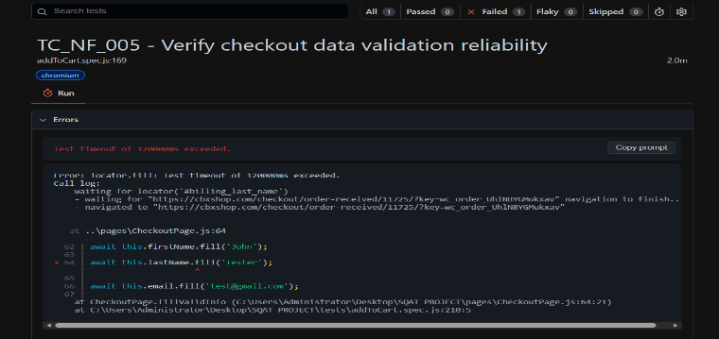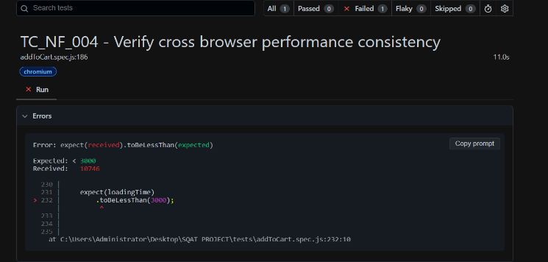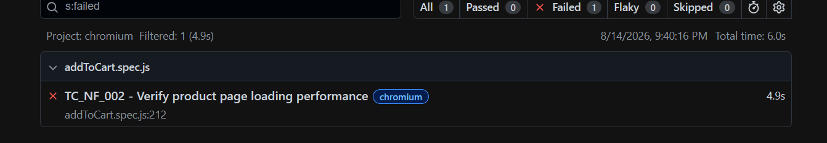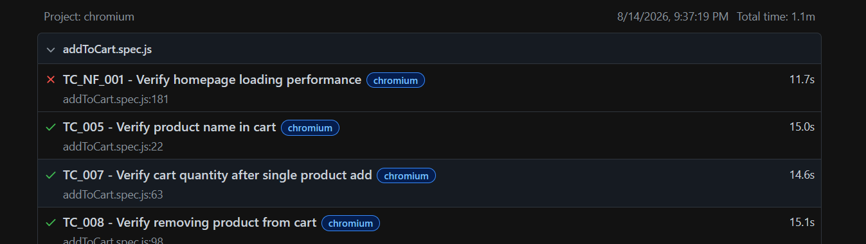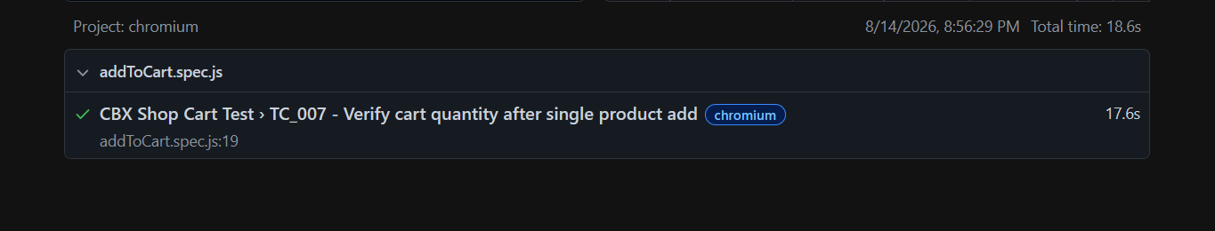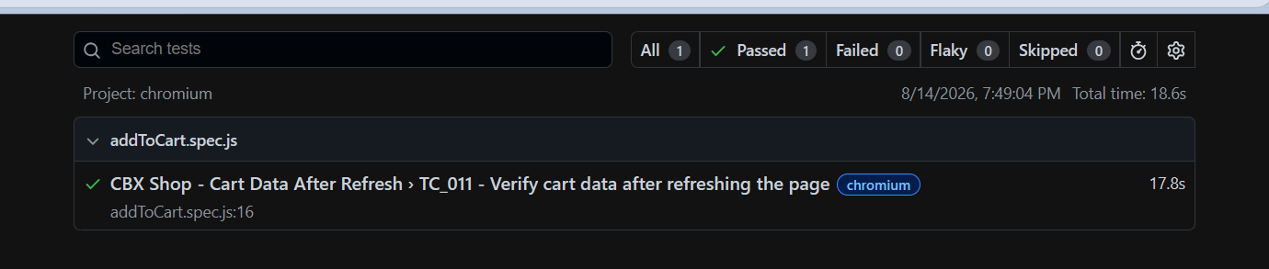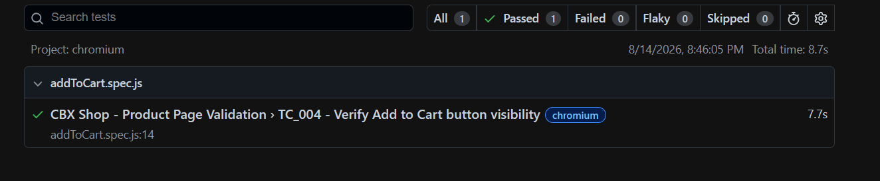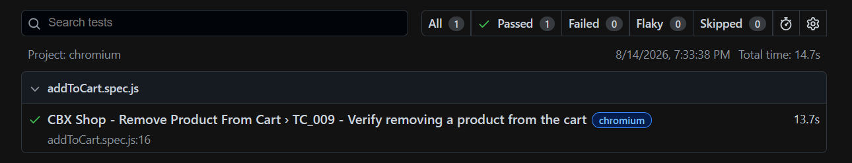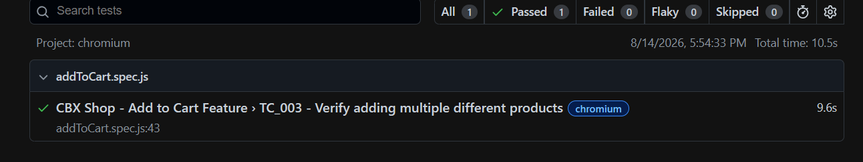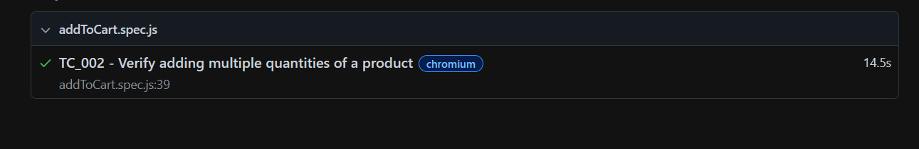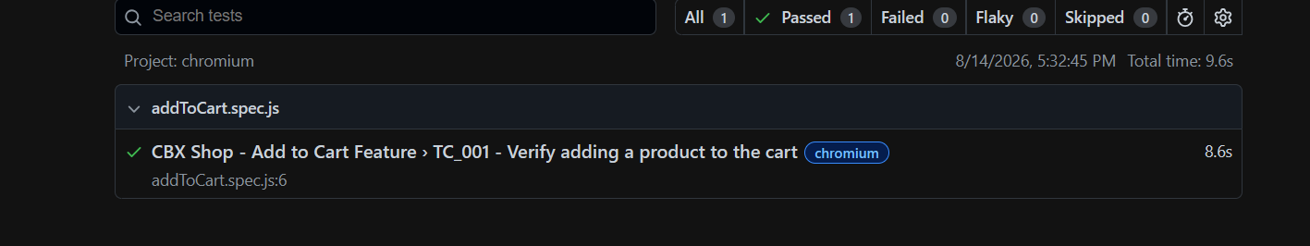

Automation Project/Repository
The Playwright automation project contains the automated test cases, Playwright configuration, test execution files, and related project files.
Automation Tool: Playwright
Test Cases Automated: 23
Functional Test Cases: 18
Non-Functional Test Cases: 5
Total Passed: 17
Total Failed: 6
Repository:

Conclusion
The Phase VI test automation was successfully performed using Playwright. A total of 23 test cases were automated and executed. Among them, 17 test cases passed and 6 test cases failed. The functional tests achieved a comparatively strong result, with 17 out of 18 tests passing. The failed cases mainly involved invalid phone-number validation and performance-related issues such as slow page loading, response time, and cross-browser performance.
The automated execution helped identify defects more efficiently and provided repeatable test results compared with manual testing. The Playwright screenshots and execution results were retained as evidence of the automation process.

